**General Description**

The prosthetic leg has two actuated joints, knee and ankle, that can be seen as a simple hinges. The knee and ankle axis of rotations are indicated in the figure to the right with dashed red lines. The distances L1, L2, and L3 indicate the lengths from the top of the pyramid adapter to the knee axis of rotation, from the knee axis of rotation to the ankle axis of rotation, and from the ankle axis of rotation to the ground, respectively. **L1 = 0.0959m; L2 = 0.3733m; L3 = 0.0628m**

Both joints have a transmission with a reduction ratio of **22:1.** Over all, the leg is designed for a maximum user weight of 250 lbs.

The prosthetic foot is an Ottobock LoRider, which has a solid keel, and therefore does not include a split heel/toes. However, future generations of the leg will include a Freedom Innovations Pacifica prosthetic foot, which does include a split heel/toes. This foot has the Item Number: FS4-00-08A27-RU, which indicates that it is Pacifica LP (FS4), Category 8 (08), size 27 (A27), and has a regular split toe (RU).

The following pages include screen shots (left) of the thigh, shank, and foot segments of the prosthetic leg. Additionally, screen shots of the mass properties of each segment is provided on the right of each page. Note that for each segment, components highlighted in blue are used for calculating the mass properties shown on the right. All mass properties are taken with respect to “Coordinate System3”, shown in blue in the figure to the right of this text. This coordinate system lies on the knee axis of rotation, and is located in the center of the knee actuator. Lastly, I’ve included red boxes to indicate specific information requested.

Please let me know if you have any questions!

Toby Elery

[toby.elery@utdallas.edu](mailto:toby.elery@utdallas.edu)

Cell: 214-504-8069

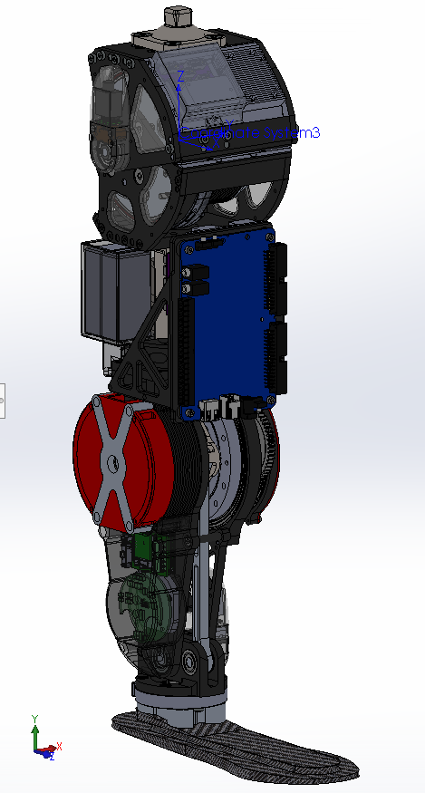

L3

L2

L1

Knee axis of rotation

Ankle axis of rotation

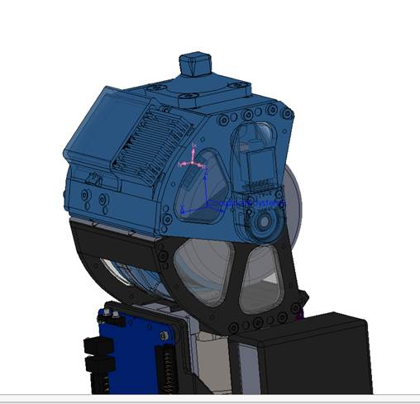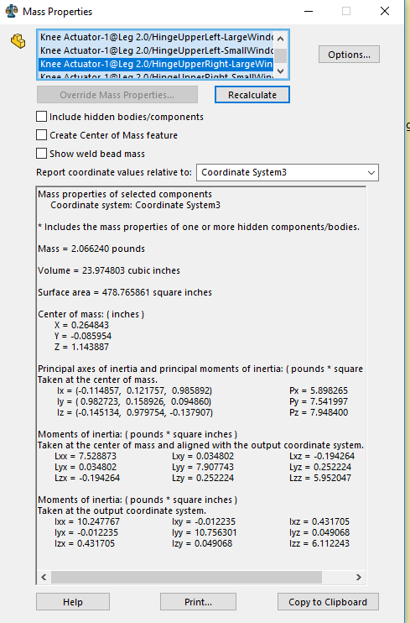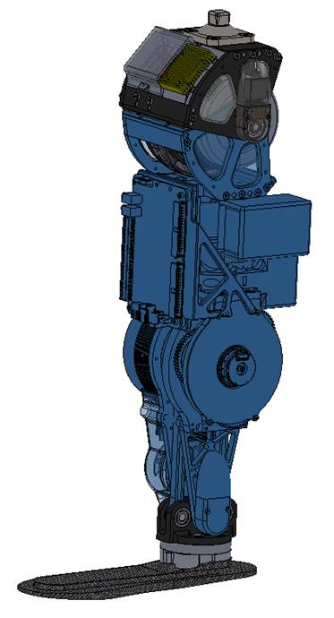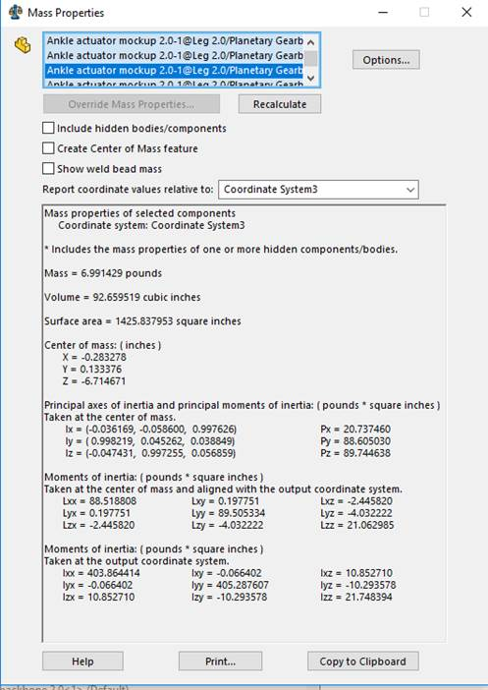

Thigh Segment

Shank Segment

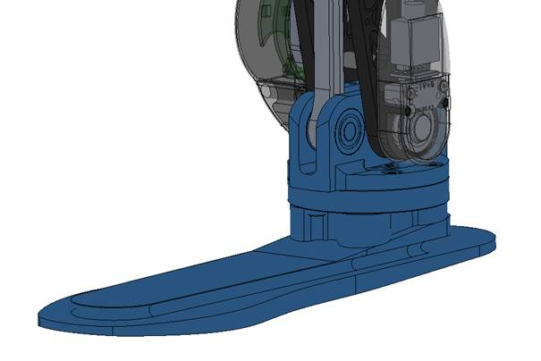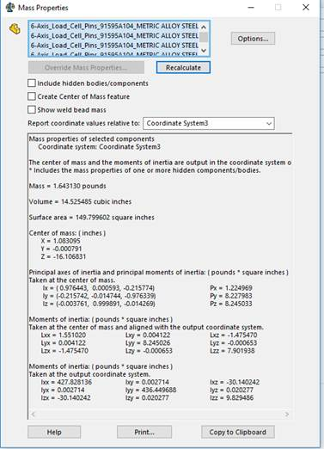

Foot Segment